**Assignment 4: Travel Agency**

Sun Ren, Yue Jian, Zeyuan Zhu

Northeastern University

**Introduction**

In the expand part of the model for the travel agency. Our group design a travel support department to help reserve hotels and rent cars. In the system customer who have booked the tickets can enjoy the service from travel support department. Travel support can help customers find hotels at the departure and arrival points of the plane. If customers have multiple stops tickets, travel support department can also help book hotels at stops. In addition, the travel support depart can help customers rent car from local car rental companies.

**Implement the model in Java**

In the original system, we have the three workarea: Airliner, Travel Support, and travel office. In the expand model we add the travel support workarea to handle a series of services related to car rental and house book. In the workarea, TravelSupport Class is the most important part in the workarea. TravelSupport get the departure and arrival locations Flight Schedule and get the customer information from customer Directory. Then TravelSupport pass information to car rental office and hotel reservation to perform the next steps.

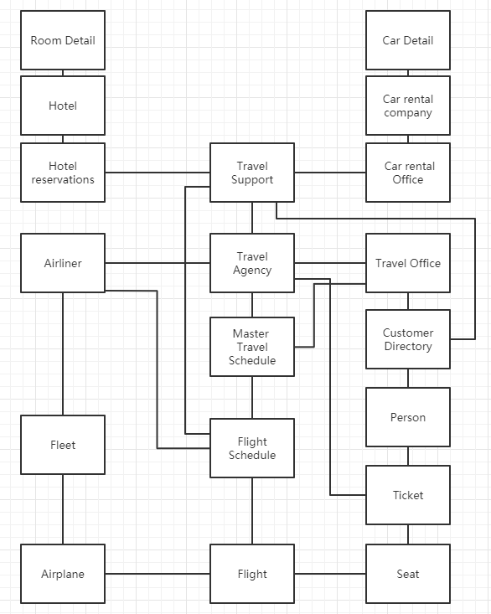

Figure-1 UML

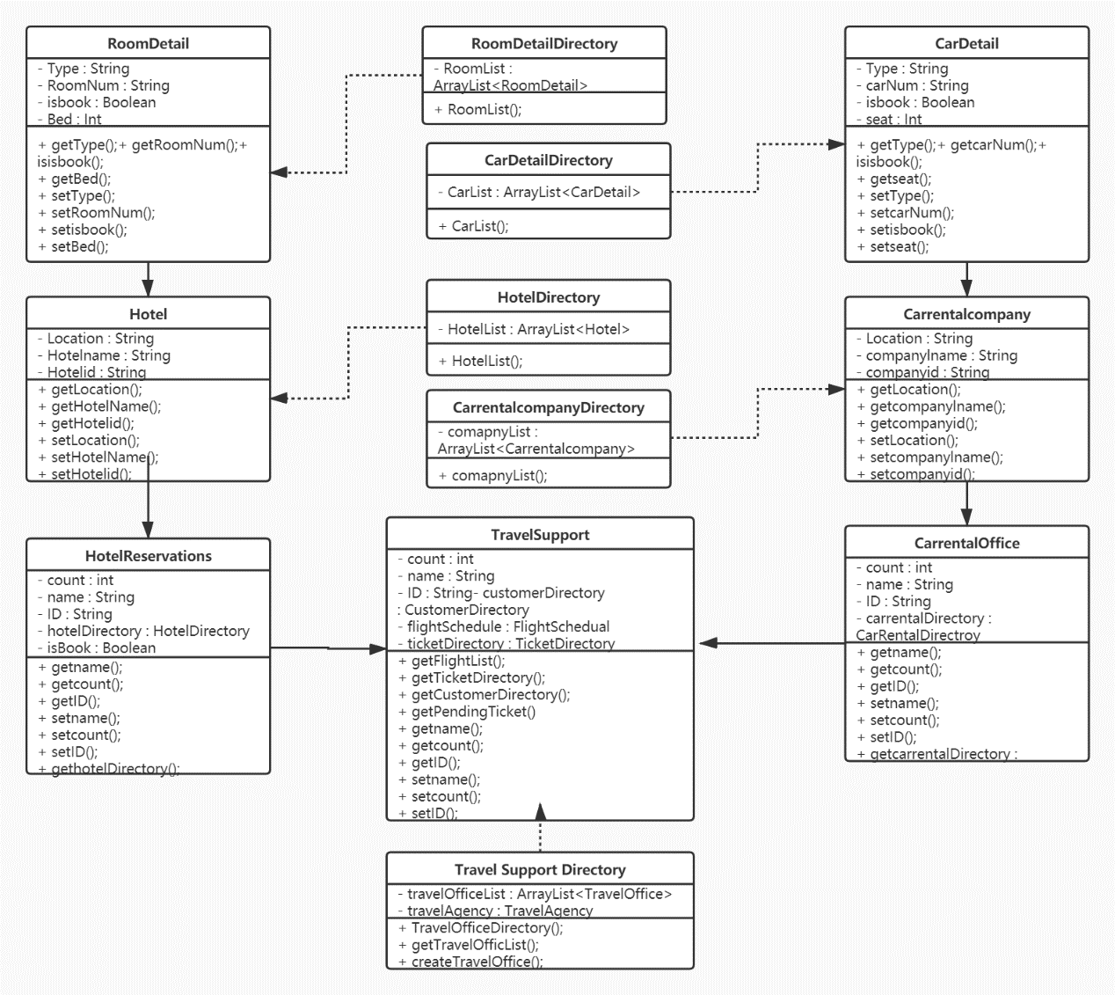

Figure-2 Class Chart

In carRentOffice part, office can get customer information such as: name, ID, &ticket from Flight Schedule and Customer Directory. Then the car rental office can contact the local car rental company in different place. And those car rental companies can provide a suitable vehicle according to your requirements.

So as Users login the TravelSupFrame, they can press the CarRentBtn and enter the CarRentFrame. There they can select a car and use the RentCar() method in control class RentCar to rent a car and add this information into CustomerDirectory. Finally the system will feedback a dialog to show that the car has been rent successfully.

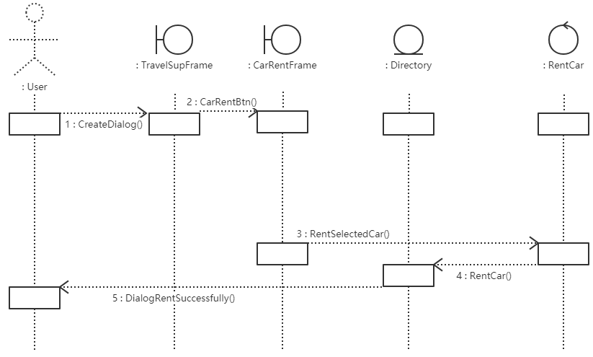

Figure-3.1 CarRent Sequence diagram

In hotelReservation part, the travel support office can also get customer information to help book a hotel. Firstly, hotelResveration access the information of customer and location to choose the bookable hotels. And for the selected hotel, it can provide the rooms to customer as customer’s request.

Also as Users login the TravelSupFrame, they can press the HotelBookBtn and enter the HotelBookFrame. There they can select a hotel and use the BookHotel() method in control class BookHotel to book a room and add this information into CustomerDirectory. Finally the system will feedback a dialog to show that the room has been rent successfully.

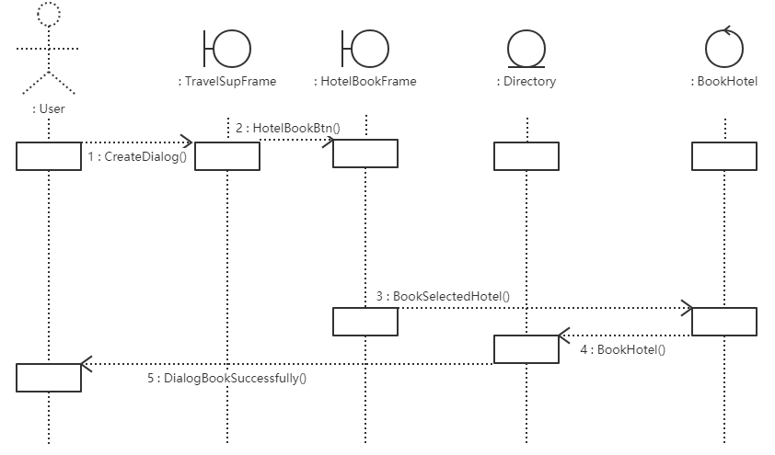

Figure-3.2 HotelBook Sequence diagram